Books to read together:
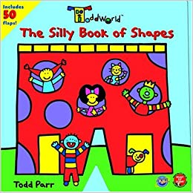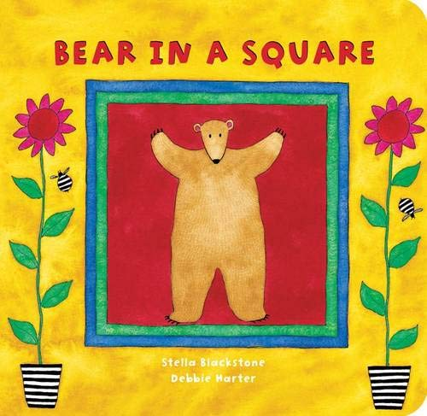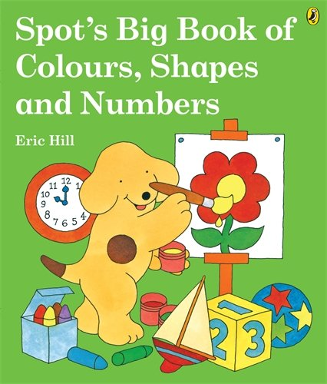

New words which I will learn:
Maths
size small medium big
shapes triangle circle square rectangle patterns zig zag dots curved straight repeated natural symmetrical edges corners sides

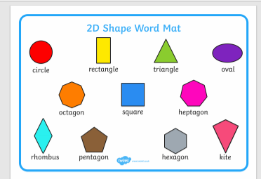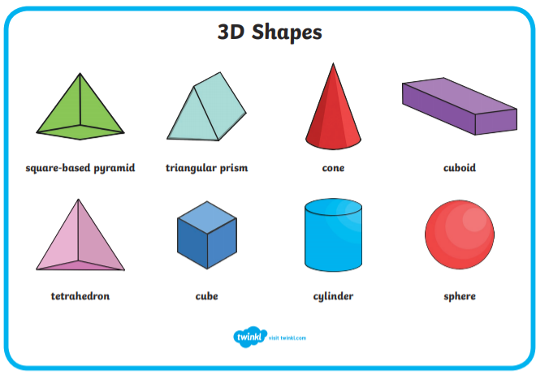
.

red yellow orange blue gold
green pink light blue black brown square circle rectangle star triangle curved patchwork

repeated pattern zig zag shapes
size big little medium large small
measure cuboid cube sphere cone

repeated patterns
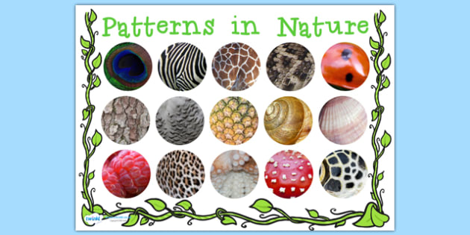
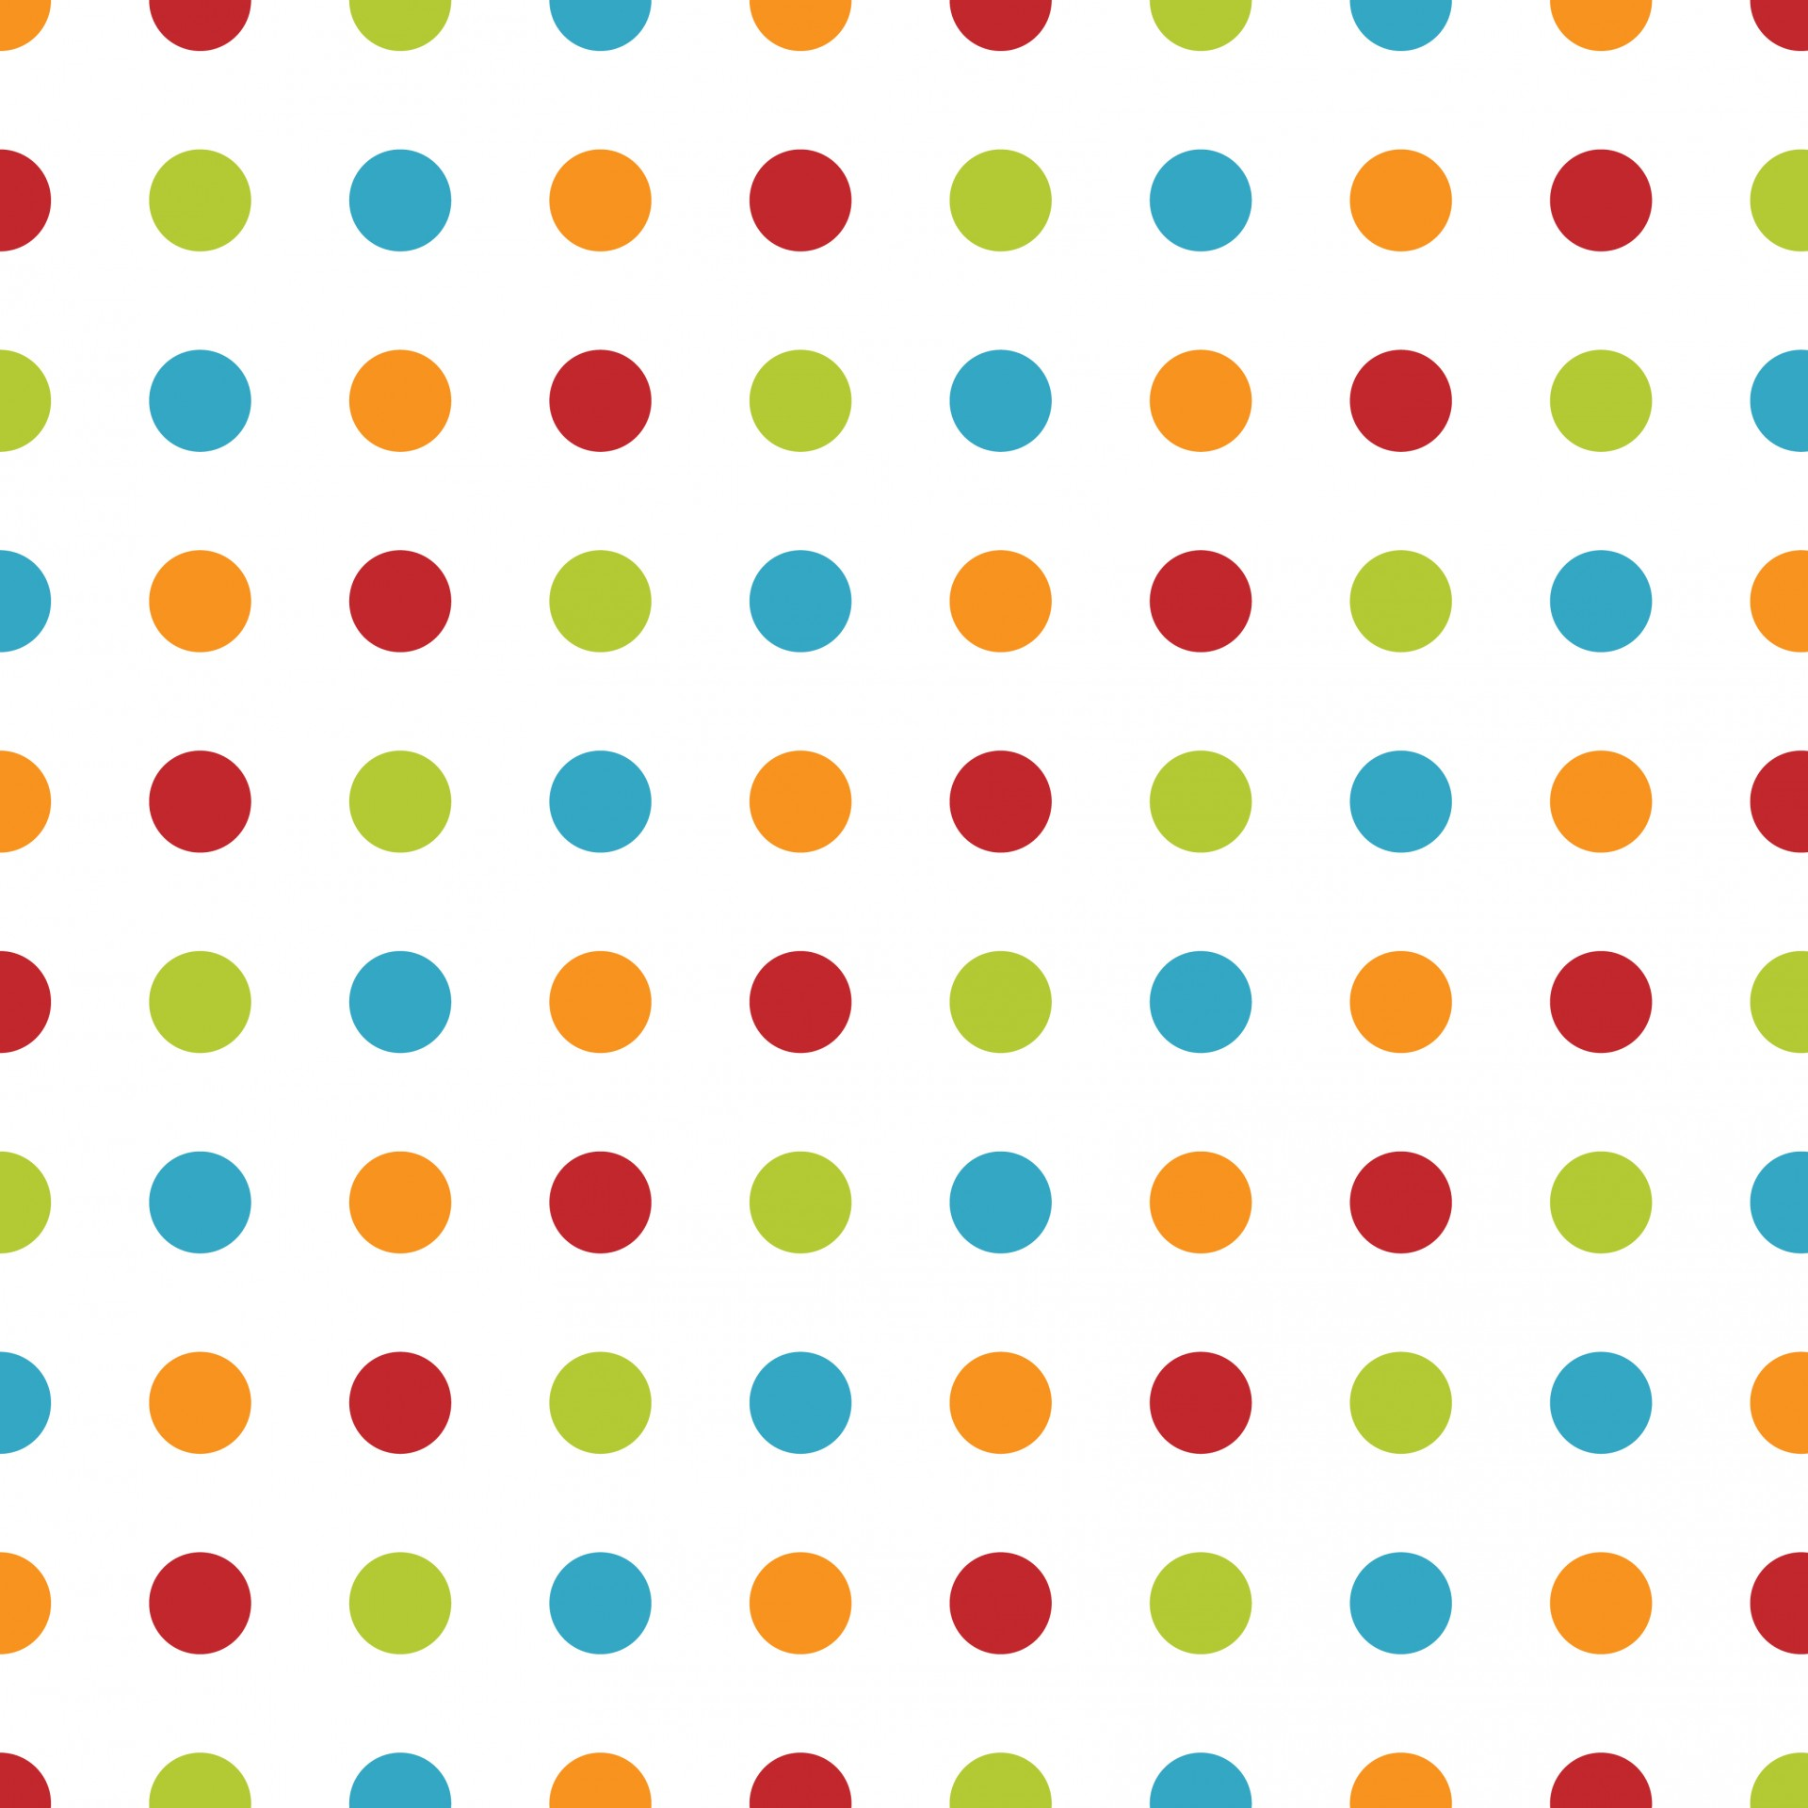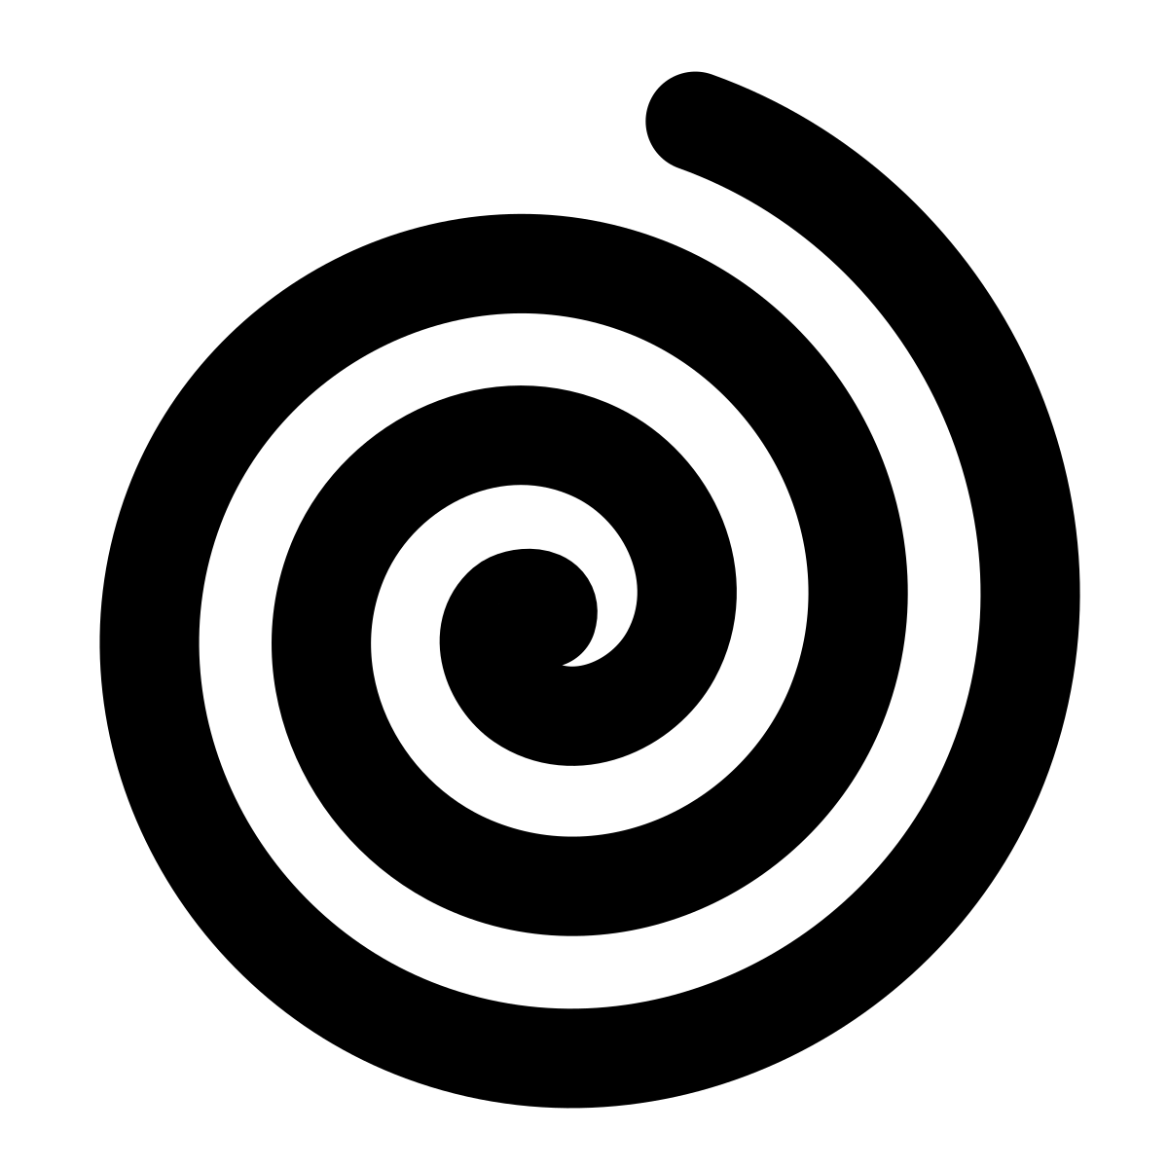
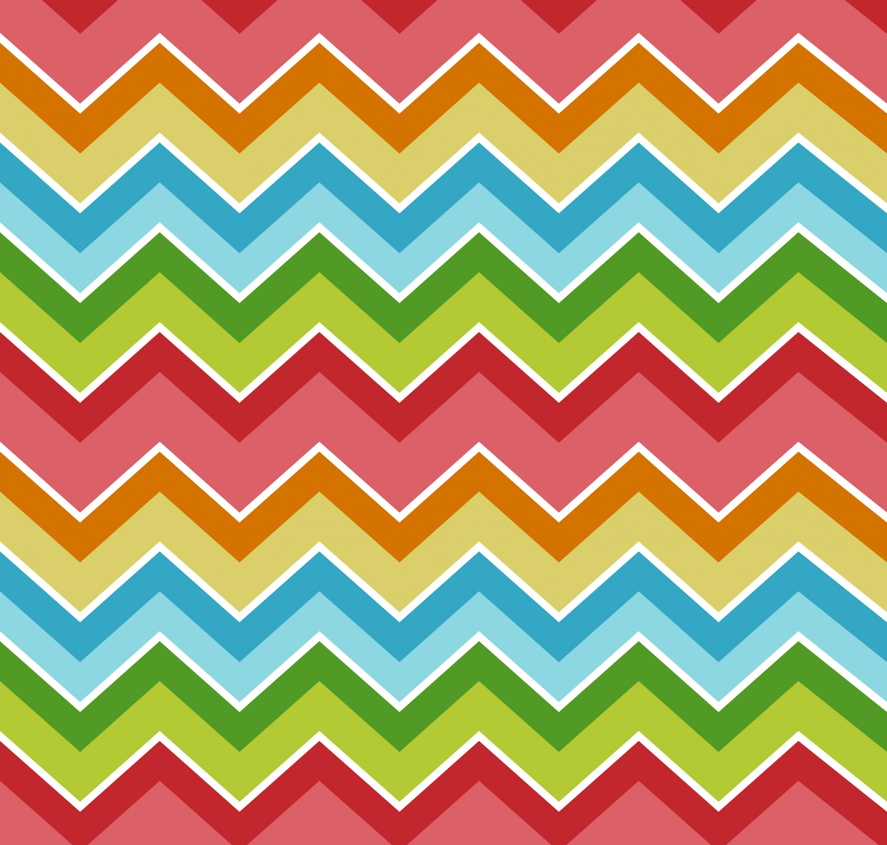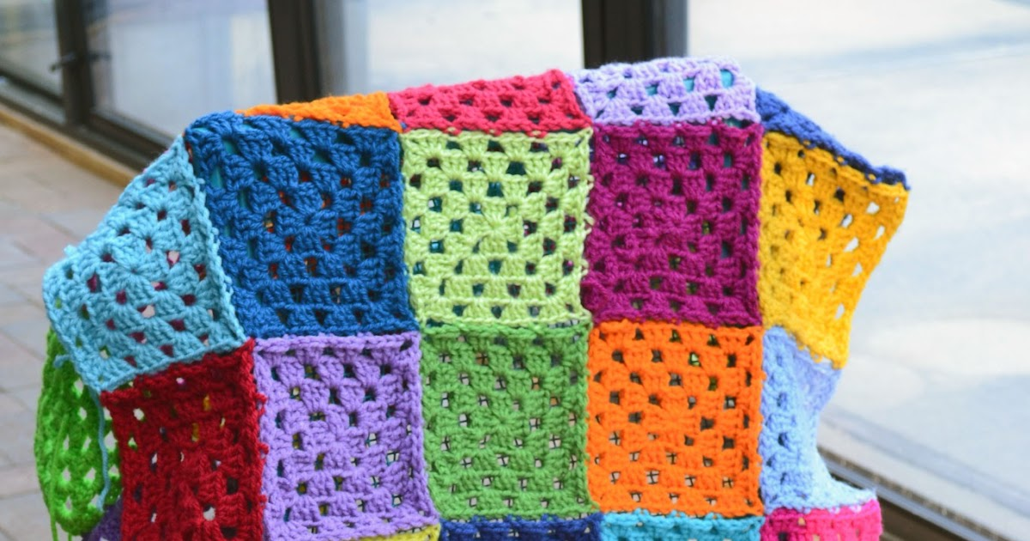
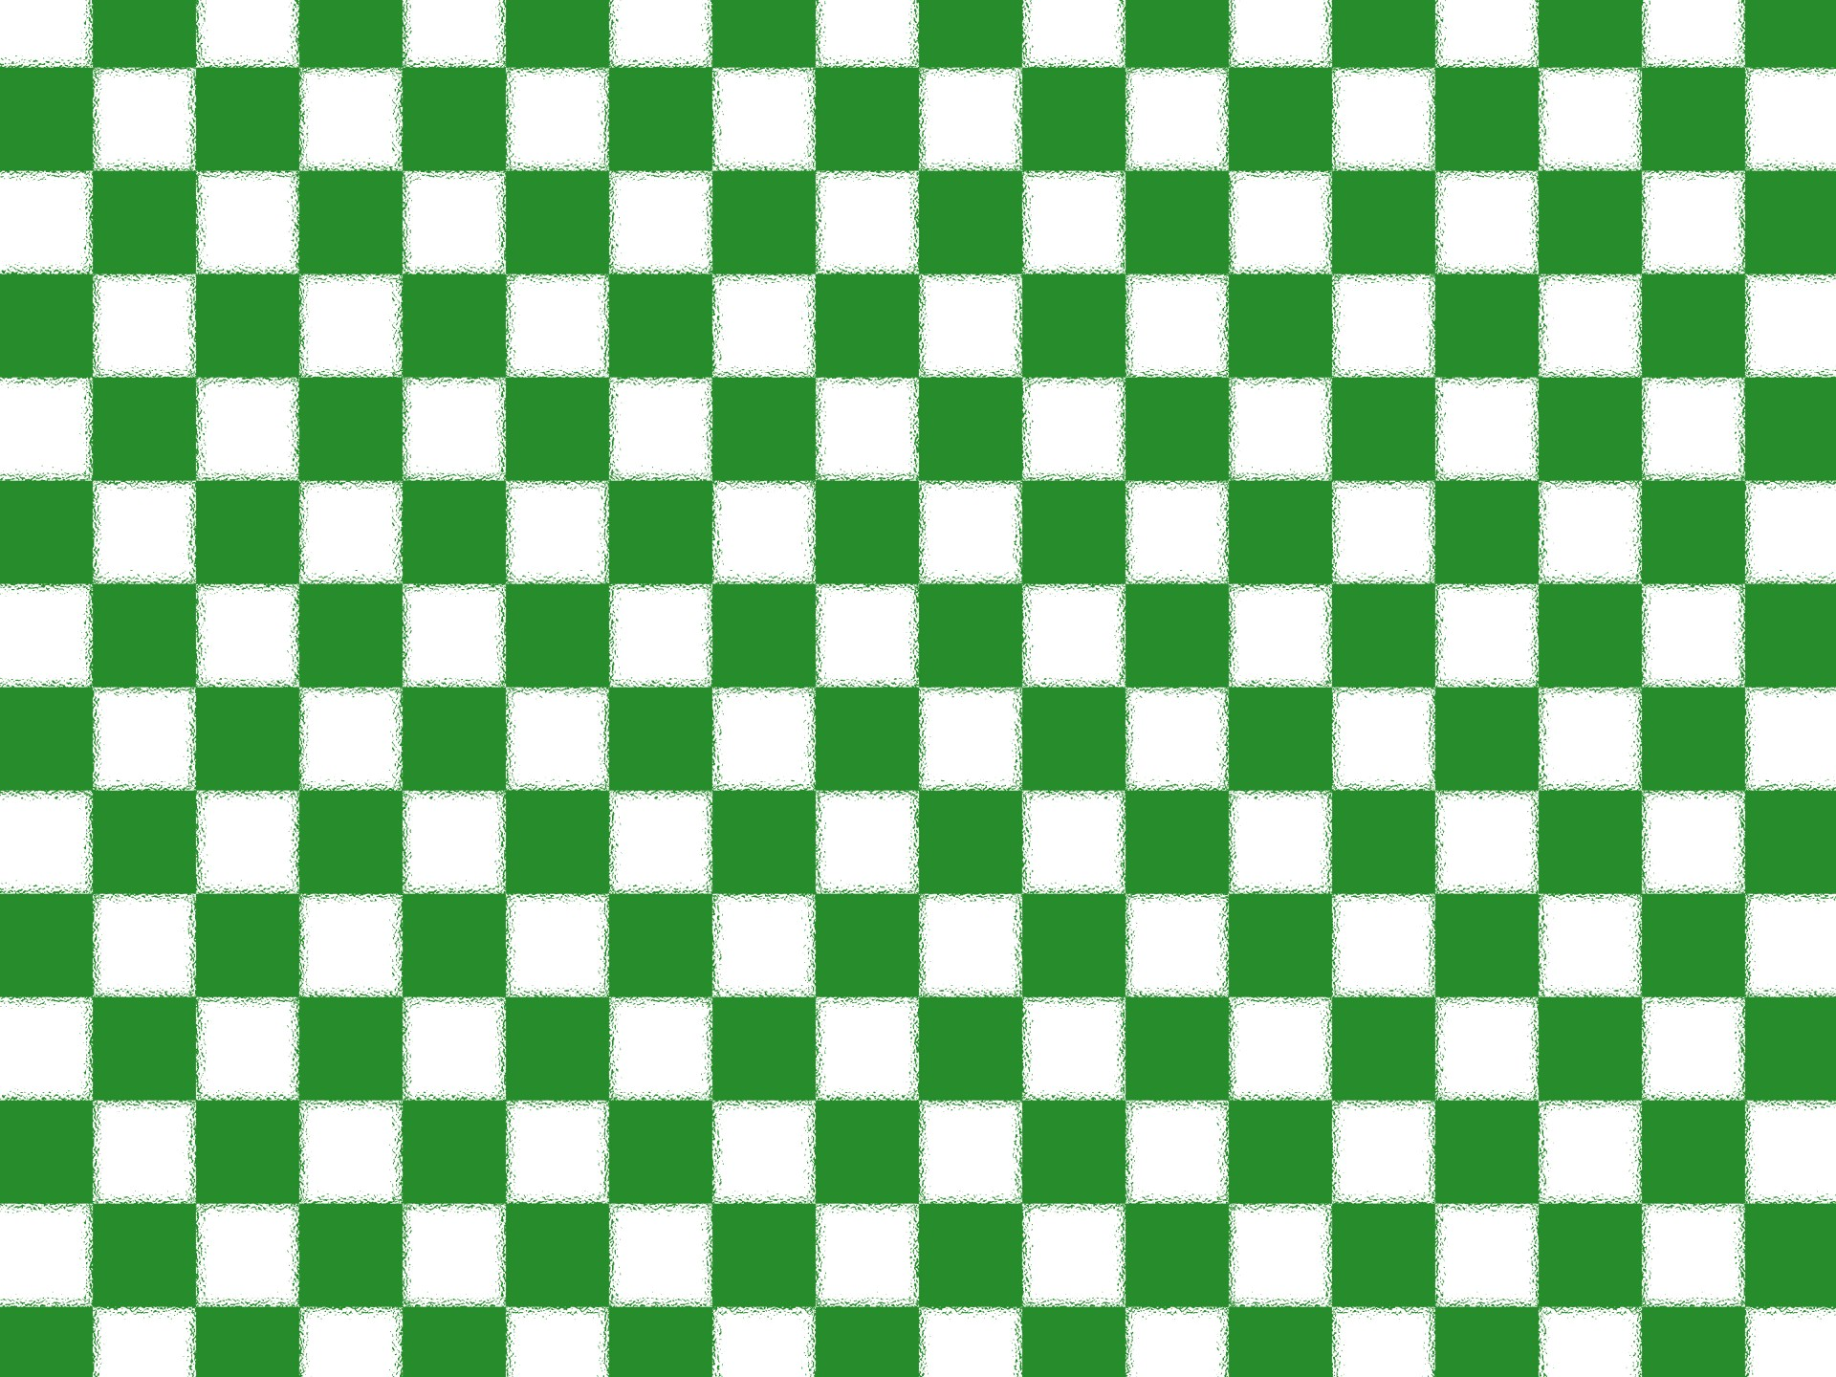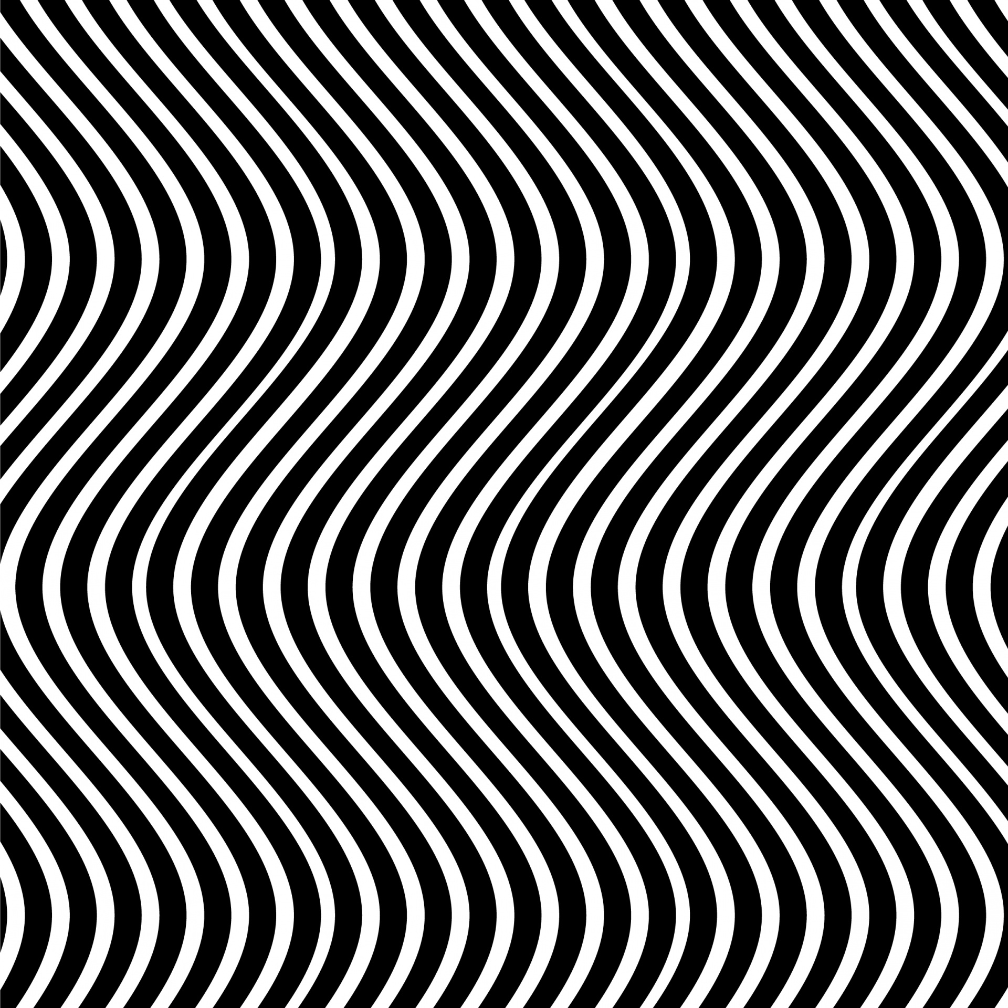

wavy
checked
zig zag
patchwork
spiral
spotty
Knowledge Organiser
Shape and Pattern

